Circuit Designing And

Implementation

Workshop

Reported By: SRPJ Group

Group Candidates Are:

1.K.Sai Ganesh Reddy

2. M.Ravi Kiran Reddy

3. G.Pradeep Reddy

4. B.Jagadeeshwar Reddy

Reported ON: 25/5/2024

Simulation Results:

1. LED ON –OFF:

a) Description of the simulation:

we have implemented LED on-off using Tinkercad. The circuit consists of the following components:

I. Power Supply: Set to provide 5.00 V.

II. Green LED: Indicates the presence of current flow.

III. 1kΩ Resistor: Limits the current to prevent damage to the LED.

IV. Slide Switch: Controls the connection, allowing the circuit to be opened or closed.

When the simulation is running, the power supply provides a constant 5.00 V to the circuit. The resistor is placed in series with the green LED to limit the current flowing through the LED, protecting it from excessive current that could cause damage. The

slide switch, when closed, completes the circuit, allowing current to flow from the power supply, through the resistor and LED, and back to the ground. This current flow causes the LED to emit light, indicating that the circuit is active. The ammeter shows a current of 3.11 mA, confirming the proper operation of the circuit

b) TinkerCad pictures(circuit layout-schematic diagram-components) : 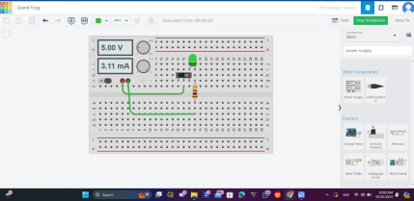1.Circuit layout

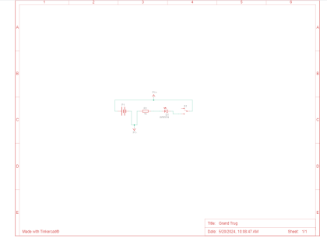2.Schematic diagram

3.Components

c) Transient Response:

The transient response occurs when the slide switch is toggled. Closing the switch completes the circuit, causing the LED to light up almost instantaneously. Opening the switch breaks the circuit, causing the LED to turn off immediately

2. Half Adder:

a) Description of the simulation:

The half-adder circuit displayed uses a breadboard setup with key components including the 74HC86 (quad XOR gate) and 74HC08 (quad AND gate) ICs, powered by a 5V supply. The inputs are connected to these gates, with the XOR gate producing the sum output and the AND gate producing the carry output. Resistors (1kΩ) are used with red and green LEDs to visually indicate the sum and carry states. The schematic shows these connections clearly, with the power supply ensuring all components are powered correctly. The transient response of this circuit involves the outputs reacting to changes in the input signals, with the XOR gate lighting up the red LED for the sum and the AND gate lighting up the green LED for the carry when both inputs are high. The current measurement of 3.01mA indicates a typical operation for the LEDs. The circuit’s propagation delay and potential brief glitches during input transitions are inherent characteristics of digital logic gates. The breadboard layout faithfully follows the schematic, ensuring correct implementation and predictable transient behavior.

b) TinkerCad pictures(circuit layout-schematic diagram-components): 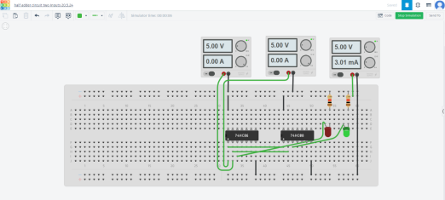1.Circuit layout

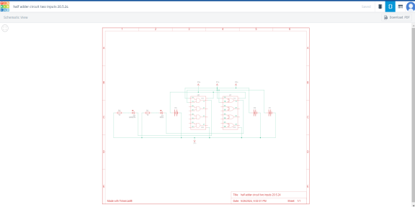2.Schematic diagram

3.Components

c) Transient Response:

During switching events from one state to another. For a half-adder circuit: i. Sum Output (XOR Gate Output): When the inputs change, the XOR gate will produce a sum output based on the exclusive OR logic. The LED connected to this output will light up accordingly.

ii. Carry Output (AND Gate Output): When both inputs are high, the AND gate will produce a carry output. The LED connected to this output will light up when both inputs are 1.

iii. Propagation Delay: There will be a slight delay from when the inputs change to when the outputs stabilize, typically on the order of nanoseconds for CMOS logic gates like the 74HC series.

Glitches/Spikes: Due to the nature of digital circuits, especially during input transitions, brief glitches or spikes might appear at the output, particularly if the inputs change simultaneously but not exactly at the same time.

3)Simple piano:

Learning Piano Theory is a fundamental component of music education, and understanding it can be the key to unlocking the mysteries of musical composition. It helps us understand why certain notes sound good together, how chords progress from one another, and how melodies are structured.

Music theory also provides insight into the creative process behind writing songs and pieces of music. By studying piano theory, we can gain valuable knowledge about harmony, melody, rhythm and form that will enhance our ability to create beautiful music. With this knowledge we can better appreciate what makes great composers so successful in their craft. With practice and dedication anyone has the potential to become a master musician starting from an understanding of basic piano theory.

In order to see the bigger picture and to quickly advance your piano theory and your playing, there is no better way than attending a piano course. At the [London Piano Centre](https://londonpianocentre.com/), you will have the opportunity to study with some of the best teachers in London, meet with other musicians and take your musicianship to the next level.

The piano is an instrument that is made up of 88 keys, each one corresponding to a different note. Note names follow the letter of the alphabet, from A to G. As a beginning piano student, it’s important to understand how notes (and note names) relate to one another on the piano keyboard, as this knowledge helps you learn and create melodies and harmonies, play songs or classical piano pieces.

**Thinkercad pictures:**

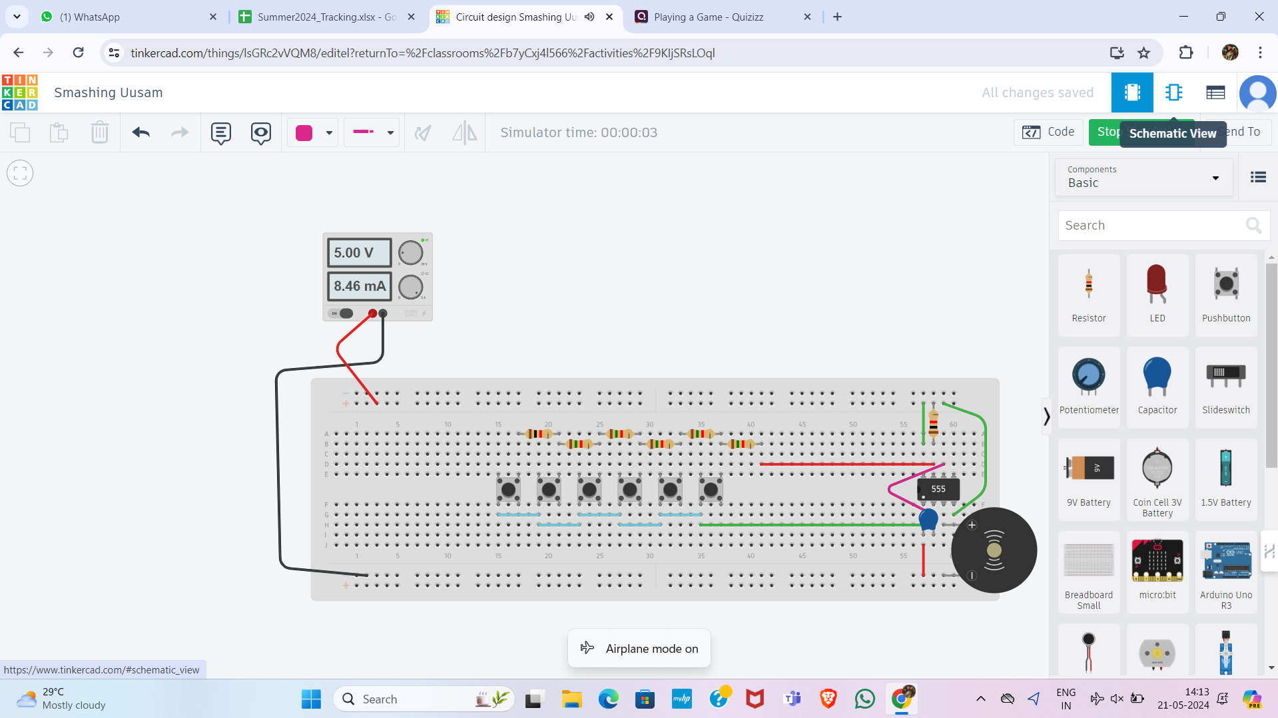

EASYEDA IMAGES:

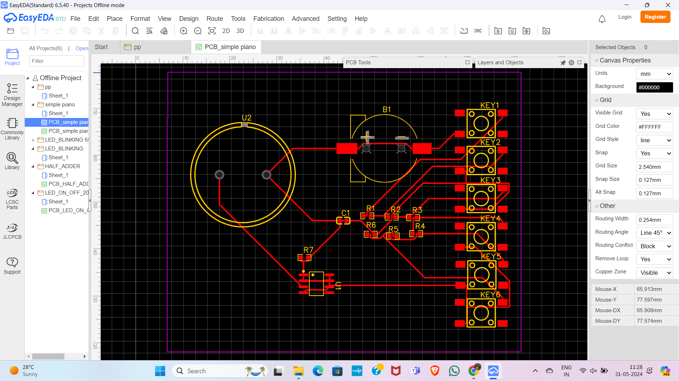

3D View:

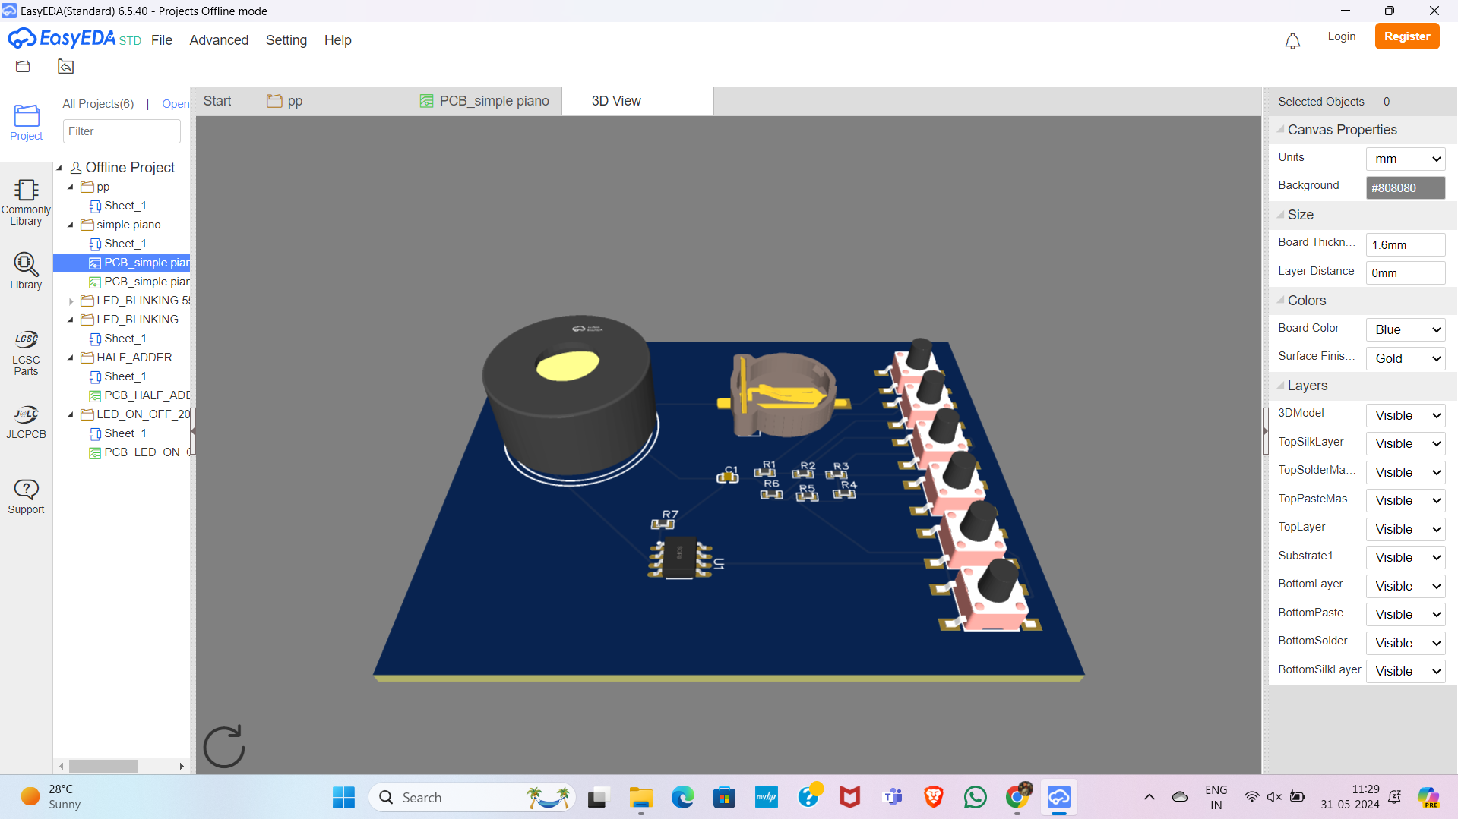

2D View:

